**Project Report**

**On**

**Online Admission System**

**BCSP-064**

**Submitted to the**

**School of Computer and Information Science,**

**TMU, Moradabad**

**In partial fulfil of the requirements**

**For**

**The award of the degree of**

**Bachelor of Computer**

**Application (BCA)**

**BY**

**Riya Chauhan**

**Enrolment No- 1801211**

**Under Guidance of**

**Retwick Bhakat**

**Introduction**

* **Title Of the Project:**

 

Online Admission System

The purpose of the project is to provide online facility to Institutes to conduct online exams and to Students to give online exams. Institutes can enter and edit the questions along with the students list. Also they can view the result. Students can login and give their respective exams and view their score then and there. Others can view sample papers to get look and feel of the online examination system.

EXISTING SYSTEM

* Currently,thesystem is totally manual.
* The manual system is slow thenthe computerized system.
* It is very time consuming.
* It is very complex system.
* It is requiredmore clericalwork and use more man power.
* The current system is not user friendly.
* It takes too much cost to perform procedure.
* In this,Paper losing or burningpaper is possible.
* It is difficult to store the data.
* **Objectives:**
* The new system is totally computerized system.
* The system should be flexible.
* It provides security and authorization.
* It save time and cost.
* It is user friendly.
* In new system,use less manpower than manual system.
* In this , the data require less space to store than the manual system.
* Students can easily get information about organization and easily apply for admission.
* **Project Category:**

Web Designing with Relational Database Management System.

* Tools/Environment:

**Tools:** Adobe Dreamweaver, XAMPP. Platform: Windows XP SP-2 and above.

**DBMS:** MySQL (XAMPP).

**Programming Language:** HTML, PHP, SQL, JQuery, Bootstrap

**Minimum Hardware Requirements:** Pentium or AMD Processor with 1.8 GHz or above, 1 GB RAM.

***Software Requirement Specification (SRS):***

**1) Introduction:**

**1.1 Purpose:** The purpose of the project is to provide online facility to Institutes to conduct online exams and to Students to give online exams. Institutes can enter and edit the questions along with the students list. Also they can view the result. Students can login and give their respective exams and view their score then and there. Others can view sample papers to get look and feel of the online examination system.

.

**1.2 Scope:** The website to conduct online Admission for a University is “**Online Admission System**”. This website provides facility to institutes to conduct online Admissions by providing a unique id to each Student. The institute provides online registration of the student. Institute also enters the list of eligible students. All the information entered can be later edited by the institute.

 In turn student can login with their id, name and Programmed to give the forms and can view their Admission status then and there. Institutes can also change the status of admission of their students (if needed).

**Benefits:** This website reduces the manual work, maintaining accuracy, increasing efficiency and saving time. Also institutes need not go to develop new software each time; instead they just register and admit the students online. For students, it saves time of going too far away admission centres and also they can view their Admission status then and there.

iii) **Abbreviations:**

PHP stands for Hypertext Pre Processor

HTTP stands for Hypertext Transfer Protocol

iv) **References:**

IEEE Recommended Practice for Software Requirements Specification- IEEE STD 830-1993.

v**) Overview:** The rest of this SRS document describes the various system requirements, interfaces, features and functionalities in detail.

2. **Overall Description:** In Online Admission system institute can register to conduct an online admission and view the academic records later. Students can fill the form and their respective academic records (softcopy), which helps the registrar to admit the student or reject as per submitted records. No student can take a particular online registration more than once.

i.) **Product**

**Perspective:**

(i) User interfaces

The application will have a user friendly and menu based interface.

Following screens will be provided:

(ii) A login screen for entering the username, password will be provided. Access to different screens will be based upon the user.

(iii) There is a screen for displaying information regarding entries to be made by institutes.

(iv) There is a screen for displaying information regarding filling of Admission form details by institutes.

(v) There is a screen for displaying information regarding entering student list for the particular program.

(vi) There is a screen for displaying information menu regarding what options the institutes will select while filling entries in the form.

(vii) There is a screen for displaying course details to the students when they are selecting program for admission.

(viii) There is a screen for submitted status for the students.

(ix) There is a screen for displaying of results of students after taking time for registrar for selecting and rejecting students in the selected list and rejected list.

(x) **Hardware interfaces**

(i) Support for printer for printing results then and there.

(ii) Screen resolution of at least 800X600 is required for proper and complete viewing of screens. Higher resolution will be accepted.

(xi) **Software interfaces**

(i) Any windows based operating system.

(ii) MYSQL-for database.

(iii) Dreamweaver for developing code.

(xii) Communications interfaces Xampp

(xiii) Memory Constraints At least 512 MB RAM and 5 MB space on hard disk will be required for running the application.

(xv) Site Adaptation Requirements Web browser with cookies enabled.

ii.) **Product Functions:** The website will allow access only to authorised users with specific roles (Administrator- maintains the website, Institutes-Register to select the forms submitted by the students, Students-Apply for admission online) a summary of the major functions that the website will perform:

a. Provide facility to institutes to register to conduct an online admission process.

b. Institutes can enter the number of programs and there course details and the list of eligible students selected.

c. Students can login and submit the admission form.

iii.) **User Characteristics:**

a. Educational level: Users should be comfortable with the English language.

b. Experience: Users should have prior information regarding the online admission process.

c. Skills: Users should have basic knowledge and should be comfortable using general purpose applications on computers.

iv.) **Constraints:**

* Since the DBMS being used is MYSQL, which is not a very popular DBMS, it will not be able to store a very huge number of records.

* Due to limited features of DBMS being used performance tuning features will not be applied to the queries and thus the system may become slow with the increase in number of records being stored.

* An extra security as SSL must be used to secure the marks details and other examination information.

v.) **Assumptions:** The application is online so taking into consideration that all the details are true. Students can submit application form just once.

vi.) **Apportioning of Requirements:** The future versions of the website will be having a better database to handle larger number of records, in a more secure way.

Also separate profile will be maintained later for all students so that he can view all his previous academic records later.

3. **Specific Requirements:** This section provides software requirements to a level of detail sufficient to enable designers to design the system and testers to test the system.

• **External Interface Requirements:**

* User Interfaces:

\***Institute Registration Screen:** Various fields available on this screen will be:

*Login Name

*Institute Name

*Email Id

*Password

\***Institute Login Screen:** Fields available on this screen are:

*Login Name

*Email Id

*Password

\***Entering academic details:** Various Fields are:

*Programs

*Course list for each Program

\***Admission selected/rejected list Screen:** Various Fields are:

*Student List Screen: Various Fields are:

*Student ID

*Student Name

*Student Login Screen: Various Fields are:

*Student ID

*Student Name

*Institute ID

*Result (Select/Reject)

\***Hardware interfaces:**

*Support for printer for printing results then and there.

*Screen resolution of at least 800X600 is required for proper and complete viewing of screens. Higher resolution will be accepted.

*Software interfaces:

*Any windows based operating system.

*MySQL-for database.

*PHP for developing code.

*Communications interfaces

None

ii.) Software Product Features:

        ♣**Validity Checks:** JavaScript provides validity checks for various fields in the forms.

         Sequencing Information: All the information regarding exam♣ details, student list, question details, display of result should be handled sequentially that is data should be stored only in a particular sequence to avoid any inconvenience

        ♣**Error Handling:** If any of the validations or sequencing flows does not hold true then

Appropriate error messages will be prompted to the user for doing the needful.

iii.) **Performance Requirements:** This subsection specifies numerical requirements placed on the software or on the human interaction with the software, as a whole. Numerical requirements will include:

*Only text information will be supported (HTTP)

*All the transactions will be processed within seconds.

iv.) **Design Constraints:** None

v.) **Software System Attributes:**

\***Security:** Only authorized users will be able to access the website by entering the correct login name and corresponding password.

\***Maintainability:** The website can be maintained in present or future. It will be easy to incorporate new requirements in the individual modules.

\***Portability:** As the website is online so will be easily portable on various systems.

The website will be also easily portable on any windows based system that has MYSQL installed.

\***Logical Database Requirements:** The following information will be placed in the database:

\***Organization Details:** ID, Login Name, Email, Password, Institute Name.

\***Program Details:** ID, Pname, No. of Course, No. of Duration, credits.

\***Institute Student List:** Sid, Sname, FormID, Result.

\***Other Requirements:** None

Giant Chart:

|  |  |  |  |  |  |  |  |  |
| --- | --- | --- | --- | --- | --- | --- | --- | --- |
| **Activity** | **01/9 - 11/9** | **12/9-30/9** | **1/10-21/10** | **22/11-15/12** | **16/12-17/01** | **18/01-12/01** | **13/02-15/02** | **16/02-26/02** |
| Project Search |  |  |  |  |  |  |  |  |
| Finalization & Allocation |  |  |  |  |  |  |  |  |
| Investigation of System Requirement |  |  |  |  |  |  |  |  |
| System design |  |  |  |  |  |  |  |  |
| Program Design |  |  |  |  |  |  |  |  |
| Program  Coding |  |  |  |  |  |  |  |  |
| System Integration |  |  |  |  |  |  |  |  |
| Acceptance Test |  |  |  |  |  |  |  |  |

DATA FLOW DIAGRAM (DFD):-

0 LEVEL DFD

**Online**

**Admission**

Login

ADMIN

USER

1 LEVEL DFD

Admission

Payment

Student Zone Manager

Admin

Student

Online Admission System

Course Manager

Student Profile create

2nd LEVEL DFD

Student profile creater

Admin

Course manager

Staff

Student

Admission

Payment

Admissiondetails

Payment G.way

StudentZone Manager

Enquiry details

Register for course

**Use Case Diagram**

View course details

Marks verification

Student Conduct

Open

Administrator

Modify course information

Close Registration

Register

Provide course information

Create Course Catalogue

Collect codes information

User

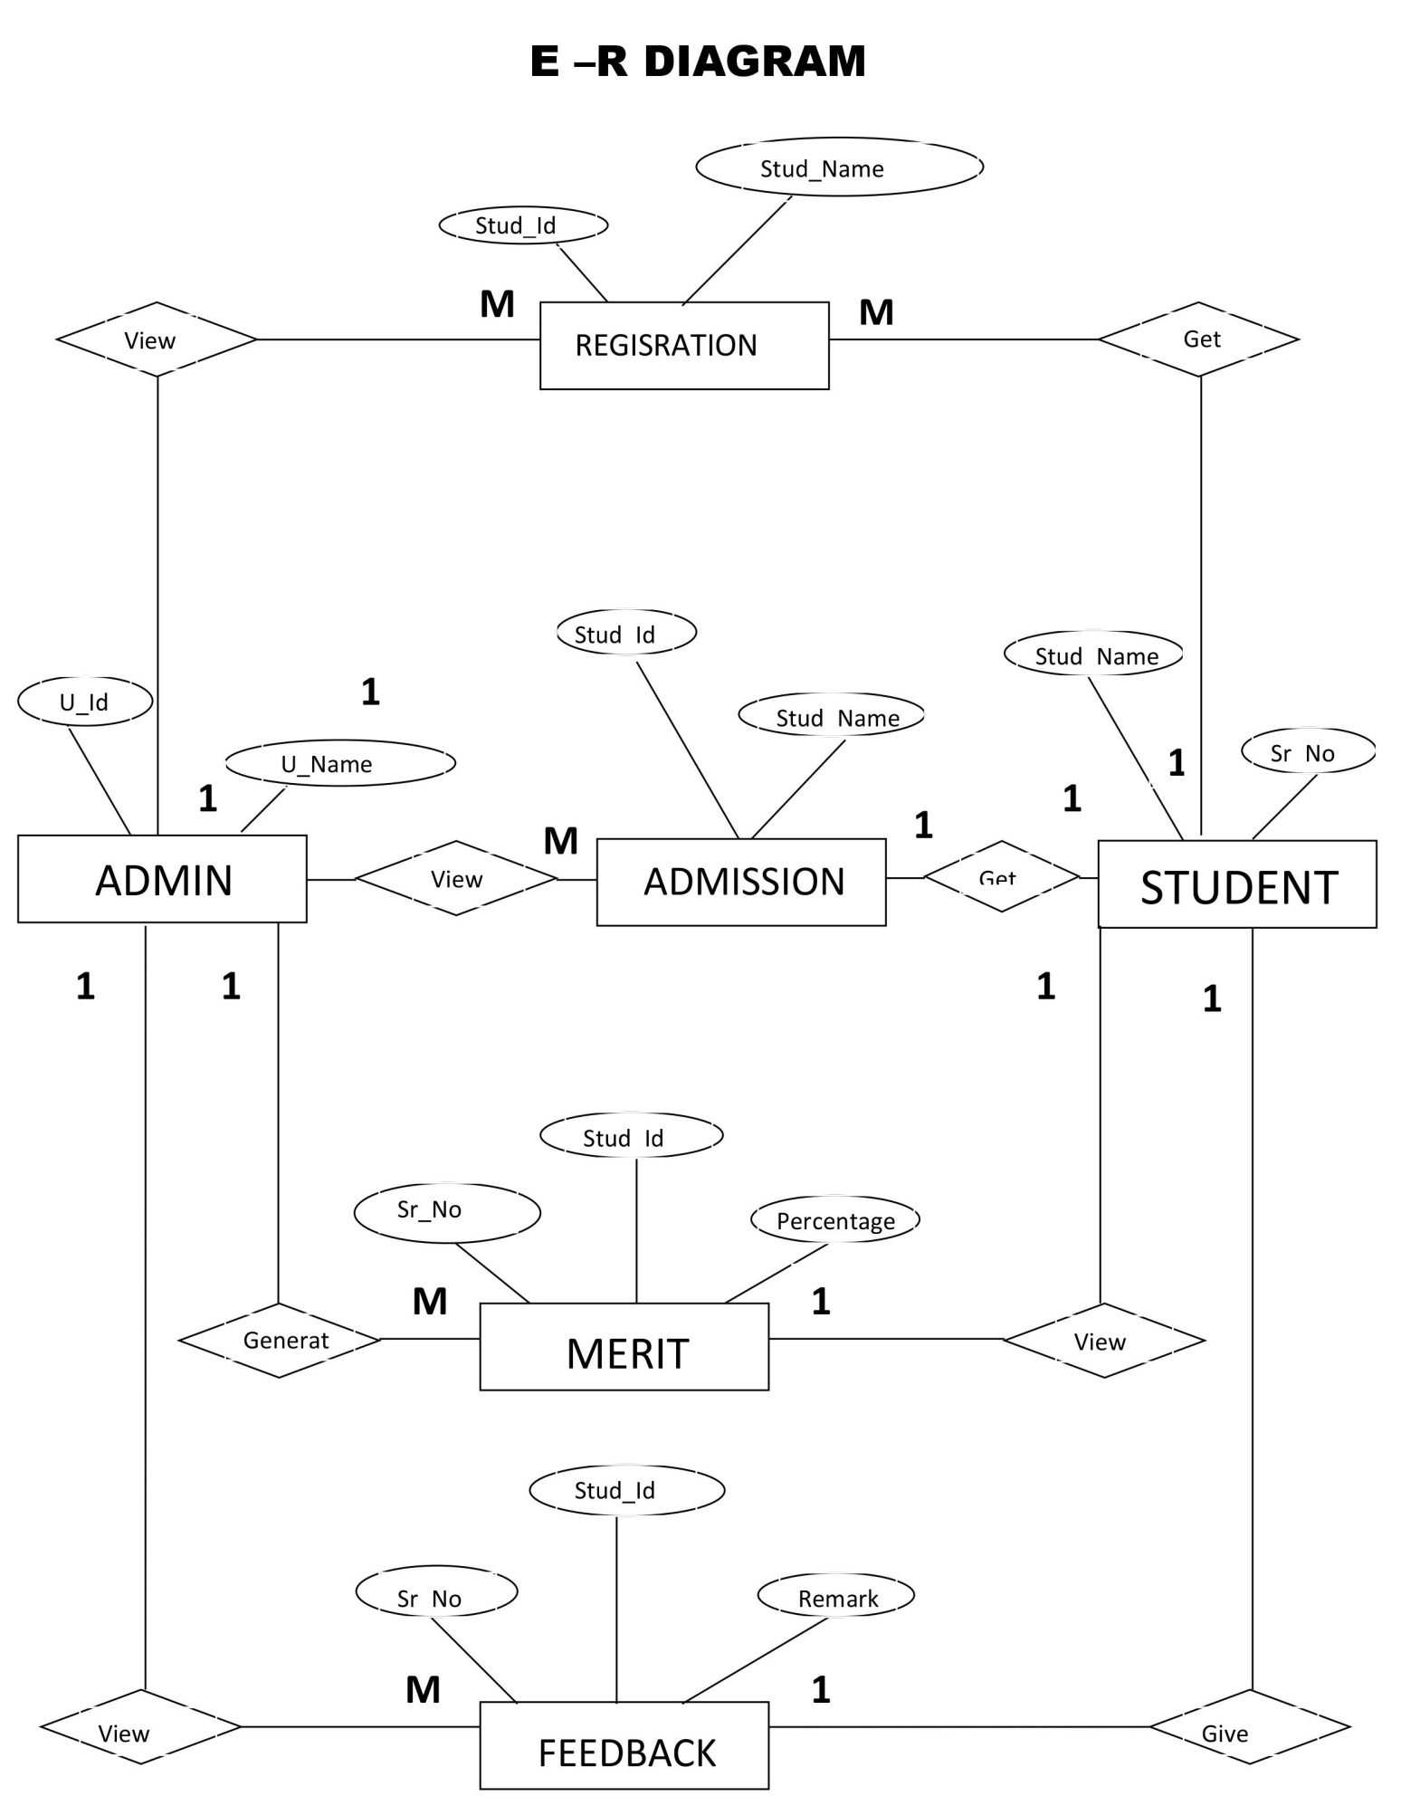

**Data Structure**

* **Table Structure In Details:**
  + **LOGIN_MST:**

|  |  |  |  |
| --- | --- | --- | --- |
| **Field Name** | **Data Type** | **Descriptions** | **Constraints** |
| U_id | Int | User id | Primary Key |
| U_name | Varchar(100) | User name | Not Null |
| Password | Varchar(100) | Password | Not Null |

* + **STAFF_MST**

|  |  |  |  |
| --- | --- | --- | --- |
| **Field Name** | **Data Type** | **Descriptions** | **Constraints** |
| Teacher_id | Int | Teacher id | Primary Key |
| Teacher_name | Varchar(20) | Teacher name | Not Null |
| Photo | Varchar(MAX) | Path | Not Null |
| Address | Varchar(MAX) | Address | Not Null |
| Contact no. | Varchar(13) | contact no. | Null |
| Qualification | Varchar(20) | Qualification | Not Null |

* + **FACILITY_MST**

|  |  |  |  |
| --- | --- | --- | --- |
| **Field Name** | **Data Type** | **Descriptions** | **Constraints** |
| F_id | Int | Facility id | Primary Key |
| F_name | Varchar | Facility Name | Not Null |
| Photo | Varchar | Path or photo | Not Null |
| Remarks | Varchar | Remarks | Null |

* + **REG_MST**

|  |  |  |  |
| --- | --- | --- | --- |
| **Field Name** | **Data Type** | **Descriptions** | **Constraints** |
| Stud_id | Int | Student id | Primary Key |
| Stud_name | Varchar | Student name | Not Null |
| Stud_city | Varchar | Student city | Not Null |
| Mobile No. | Int | Mobile no. | Not Null |
| Username | Varchar(20) | Username | Not Null |
| Password | Varchar(10) | Password | Not Null |

* + **ADMISSION_DETAIL**

|  |  |  |  |
| --- | --- | --- | --- |
| **Field Name** | **Data Type** | **Descriptions** | **Constraints** |
| **Sr_no** | **Int** | **Serial no.** | **Primary Key** |
| **Stud_id** | **Int** | **Student id** | **Foreign Key** |
| **Stud_Name** | **Varchar(20)** | **Student Name** | **Not Null** |
| **Father_Name** | **Varchar(20)** | **Father name** | **Not Null** |
| **Occupation** | **Varchar(20)** | **Father Occupation** | **Not Null** |
| **Address** | **Varchar(MAX)** | **Address** | **Not Null** |
| **Birthdate** | **Date** | **Birth Date** | **Not Null** |
| **Cast** | **Varchar(20)** | **Cast** | **Not Null** |
| **Gender** | **Varchar(5)** | **Gender** | **Not Null** |
| **Passed_standard** | **Varchar(10)** | **Last Standard** | **Not Null** |
| **Last_School_Name** | **Varchar(20)** | **School Name** | **Not Null** |
| **Last_Year_Result** | **Varchar(10)** | **Result** | **Not null** |
| **Stream** | **Varchar(10)** | **Stream** | **Null** |

* + **MERIT_DETAIL**

|  |  |  |  |
| --- | --- | --- | --- |
| **Field Name** | **Data Type** | **Descriptions** | **Constraints** |
| **Sr_no.** | **Int** | **Serial Number** | **Primary Key** |
| **Stud_id** | **int** | **Student Id** | **Foreign Key** |
| **Stud_Name** | **Varchar(20)** | **Student Name** | **Not Null** |
| **Percentage** | **Varchar(5)** | **Student Percentage** | **Not Null** |

* + **FEEDBACK_DETAIL**

|  |  |  |  |
| --- | --- | --- | --- |
| **Field Name** | **Data Type(Size)** | **Descriptions** | **Constraints** |
| **Sr_no.** | **int** | **Serial Number** | **Primary Key** |
| **Stud_Id** | **int** | **Student Id** | **Foreign key** |
| **Stud_Name** | **Varchar(20)** | **Student Name** | **Not Null** |
| **Remarks** | **Varchar(Max)** | **Student Remarks** | **Null** |

POST IMPLIMENTATION REVIEW

* The performance level of users has improved.
* The system needs less paper work, save time, secure data.
* Admin can work very quickly.
* There is various information which should be retrieved very easily.

FUTURE ENHANCEMENT

There is one segment named lab unit needed computer system to improve work. In this system, we tried to make a simple application for user. We can change our system day by day as per user requirements will be changed. In future, we want to implement below point in our system.

* We can generate student attendance report.
* We can generate graphical report of student’s result.